

Parallel programming project 3

LAKHAN JHAWAR-R11067581



May 4, 2014

TTU

CS5379/4379

Contents

Question 1: 2

Output: 2

Table: Input size is 2000 5

Plot: 5

Question 2 a: 6

Output: 6

Table: 9

Plot: 9

Question 2 b: 10

Output: 10

Table: 13

Plot: 14

Comparison Graph: 14

# Question 1:

## Output:

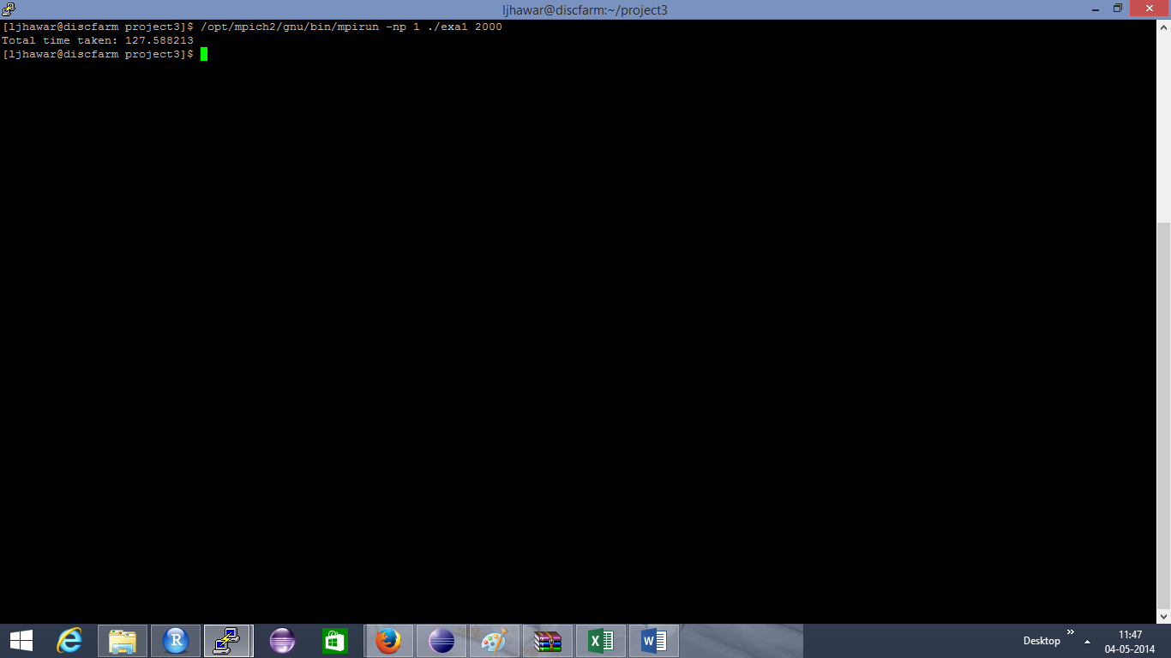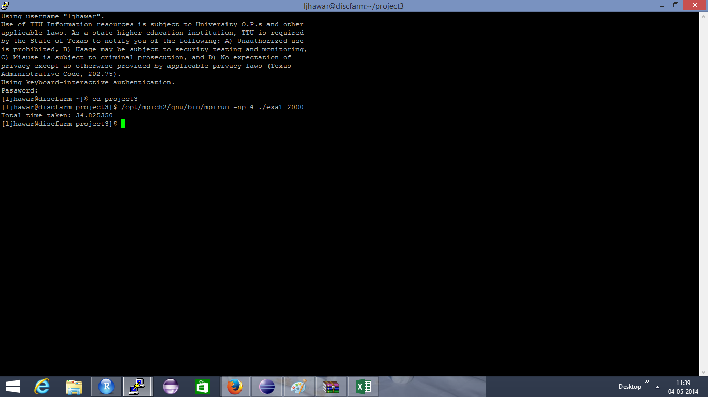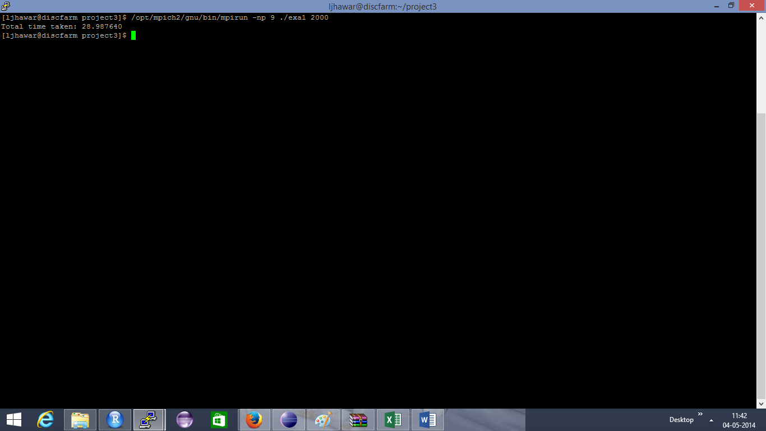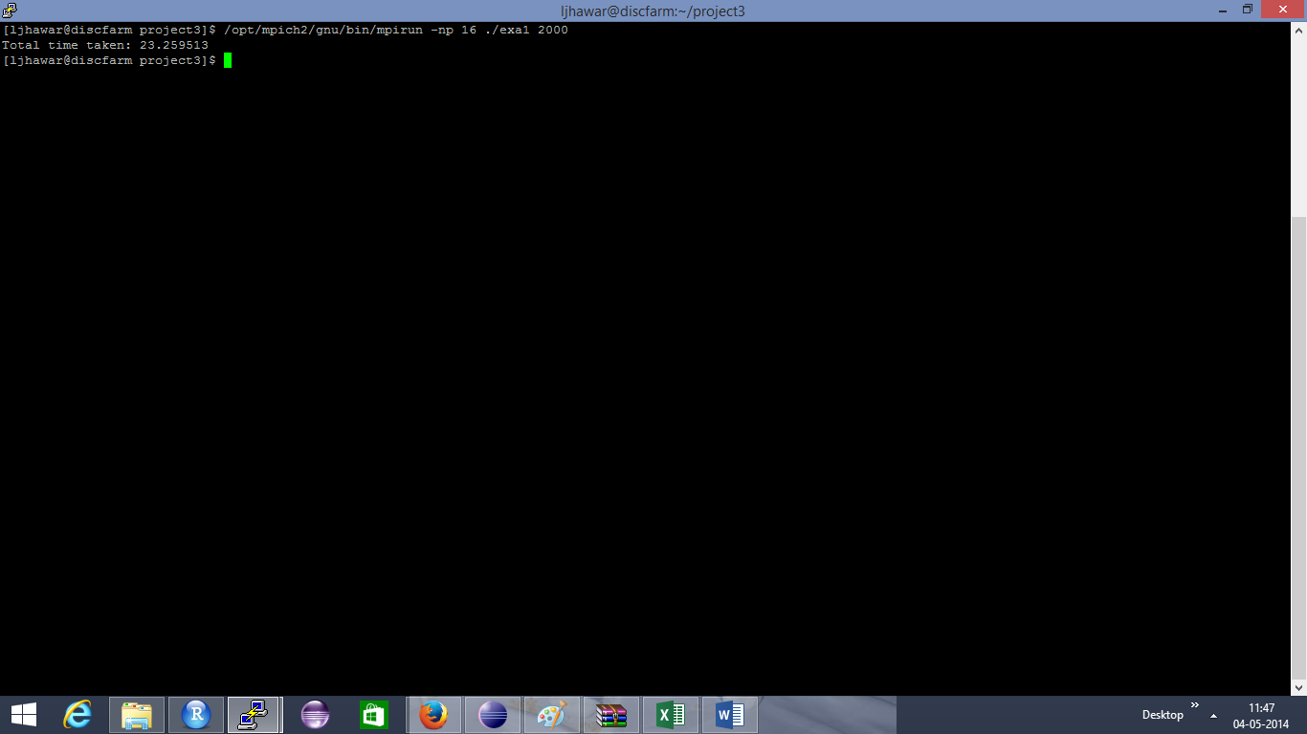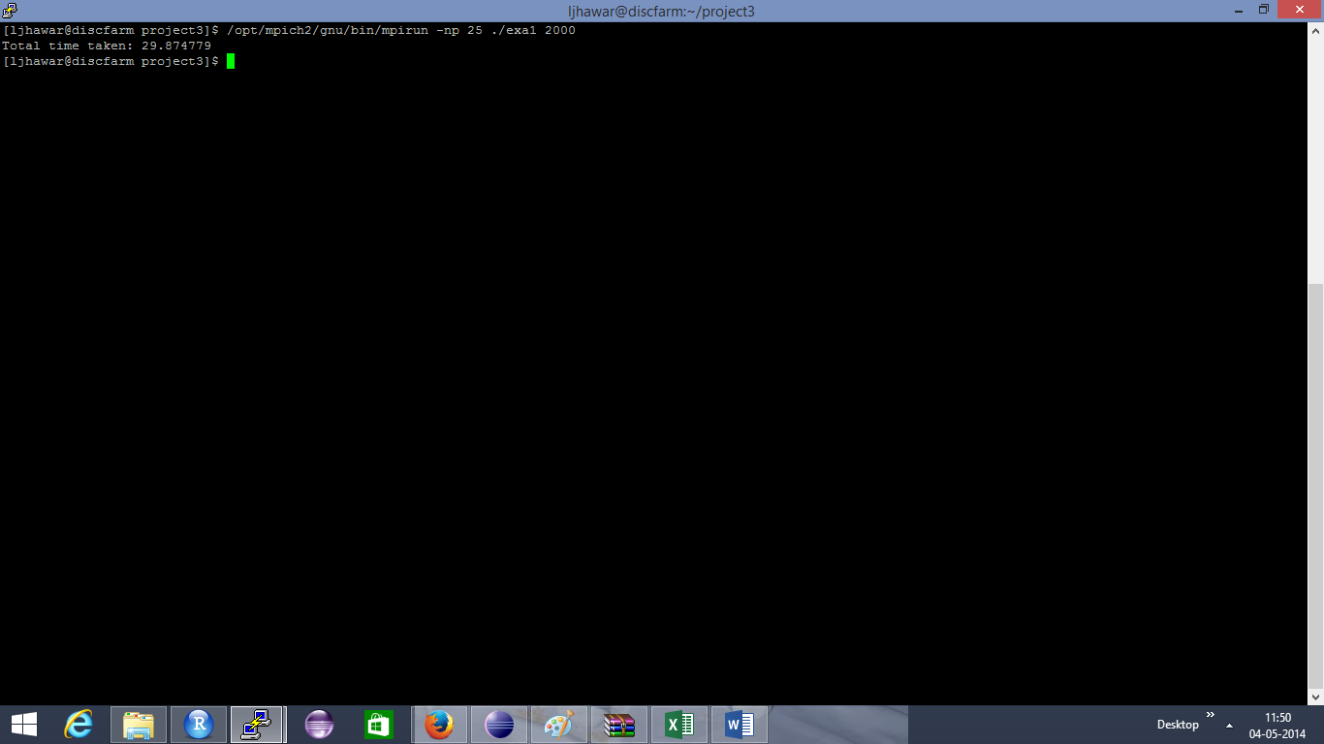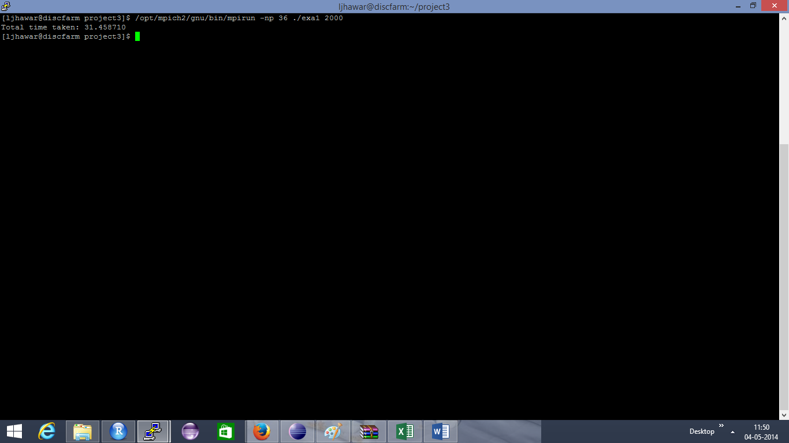

## Table: Input size is 2000

|  |  |
| --- | --- |
| Number of processors | Total time |
| 1 | 115.491056 |
| 4 | 34.825350 |
| 9 | 28.987640 |
| 16 | 23.259513 |
| 25 | 29.874779 |
| 36 | 31.458710 |

## Plot:

# Question 2 a:

## Output:

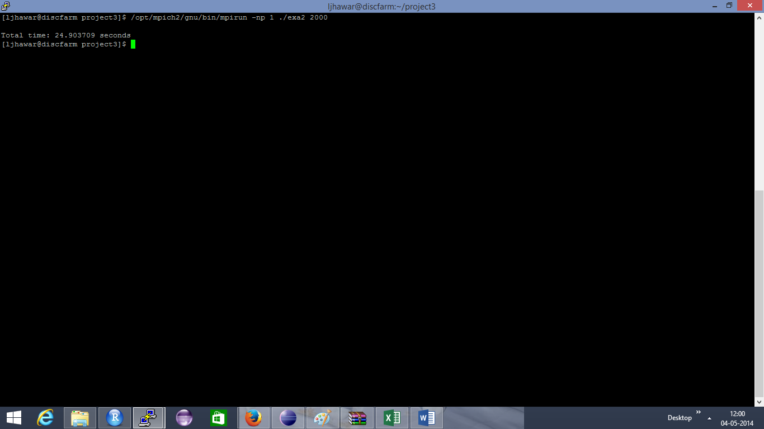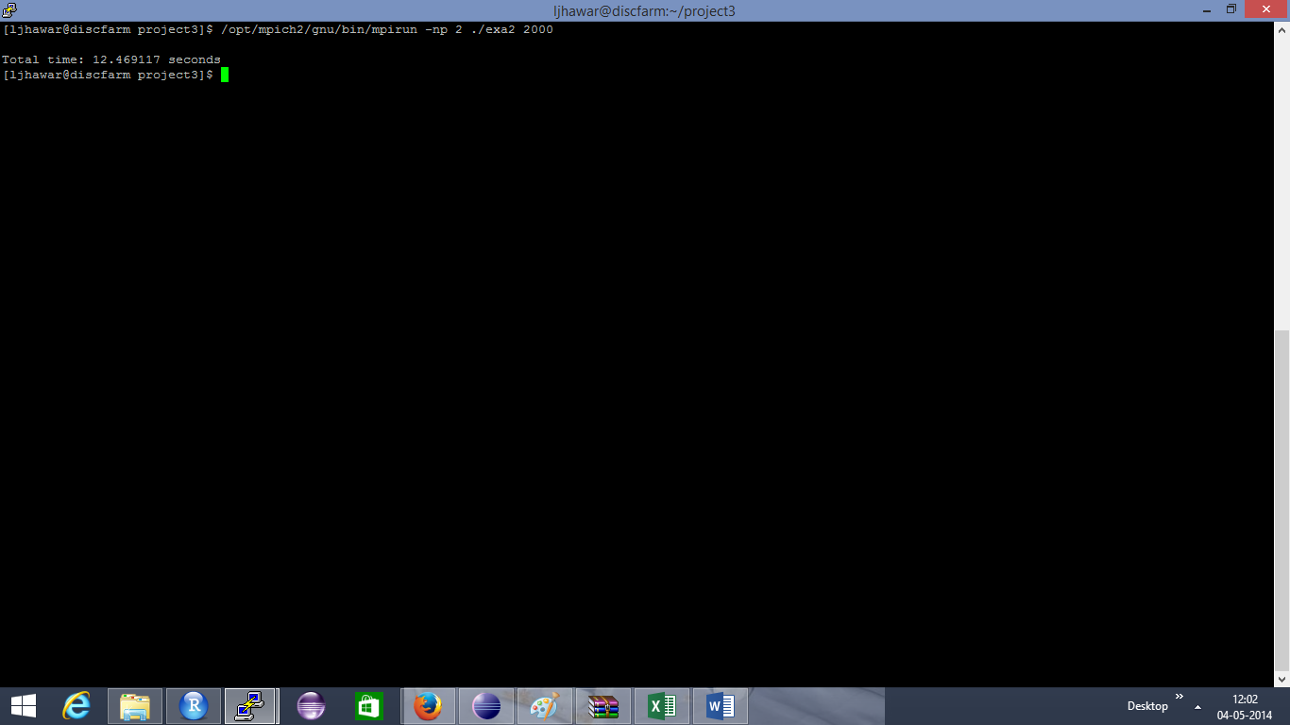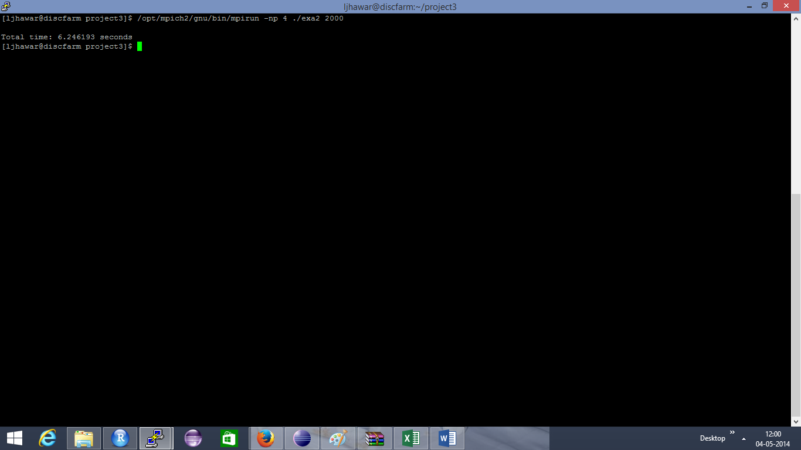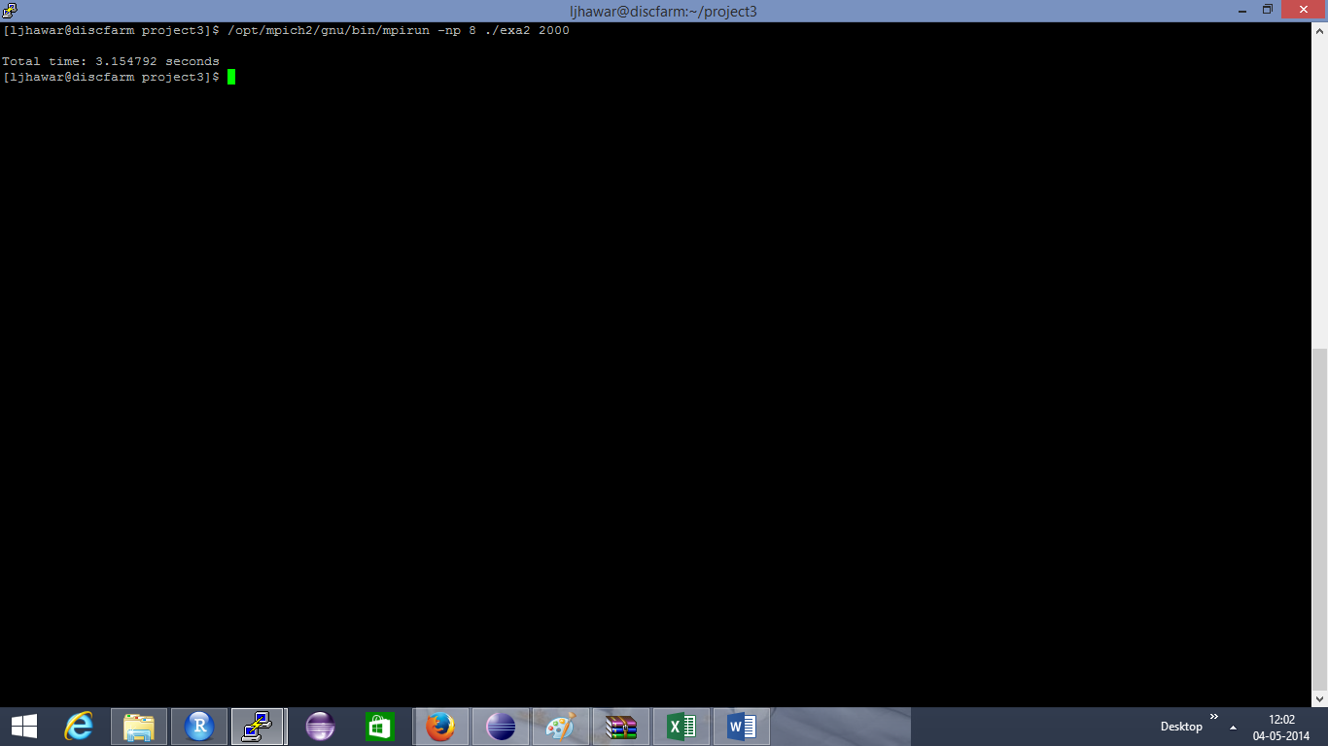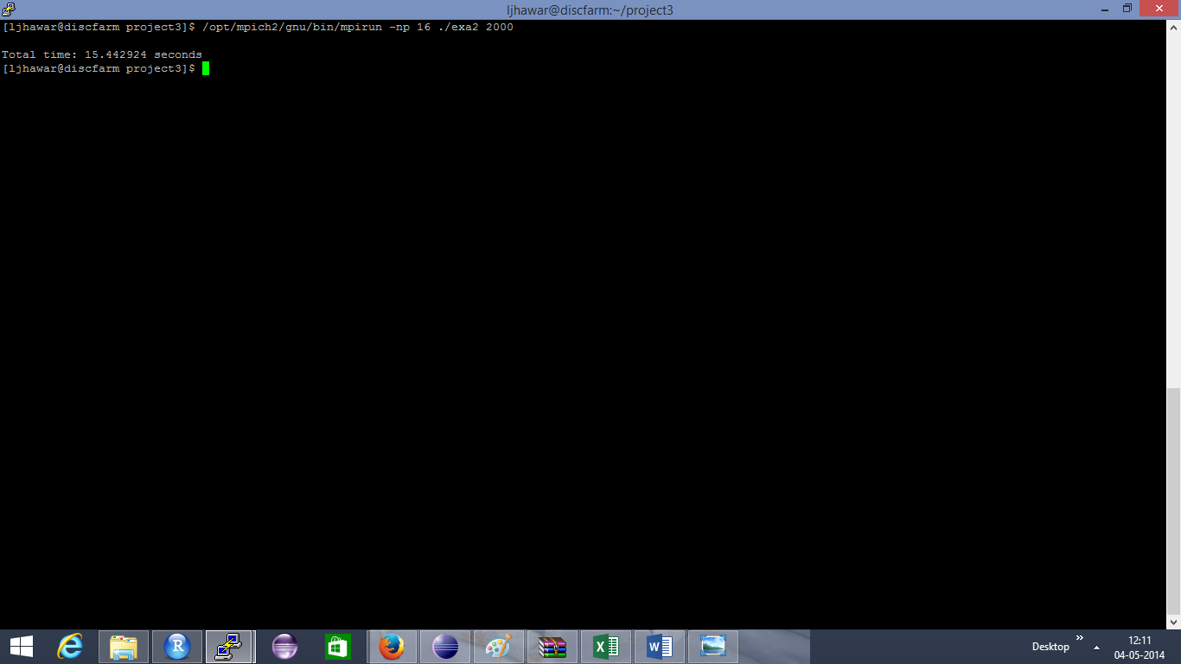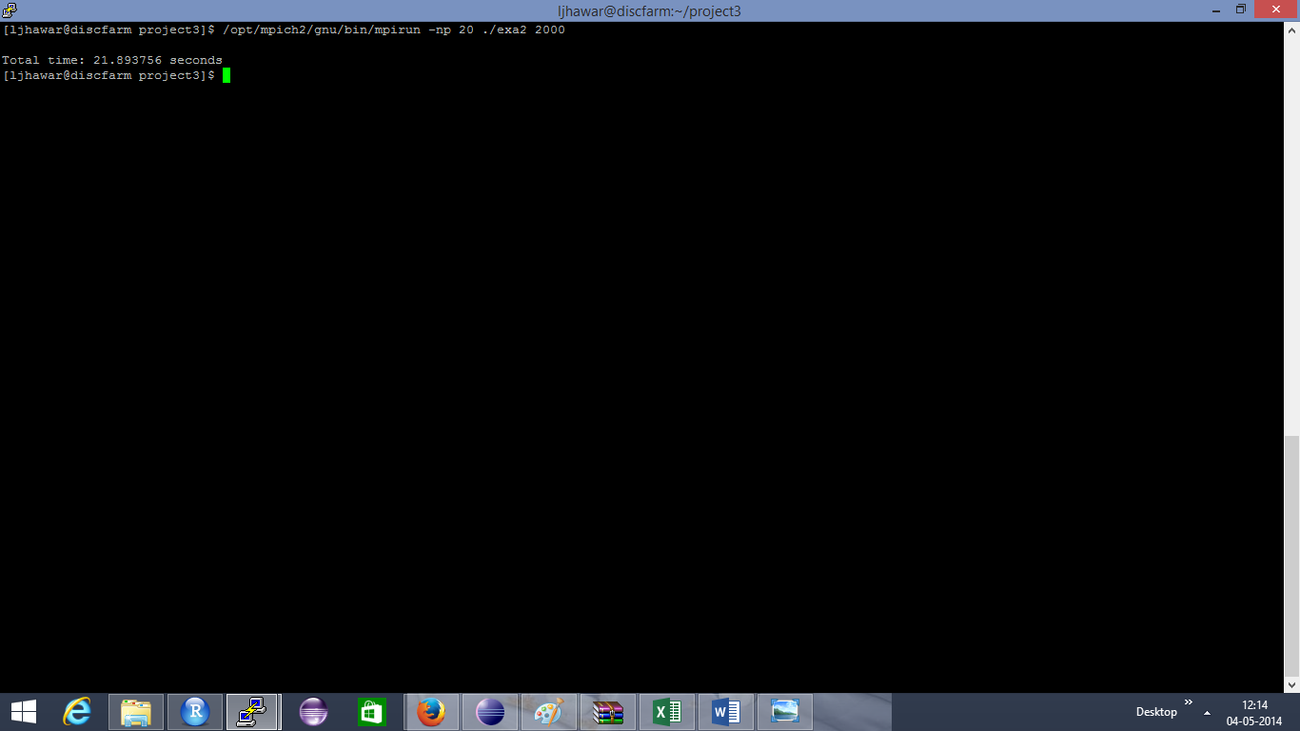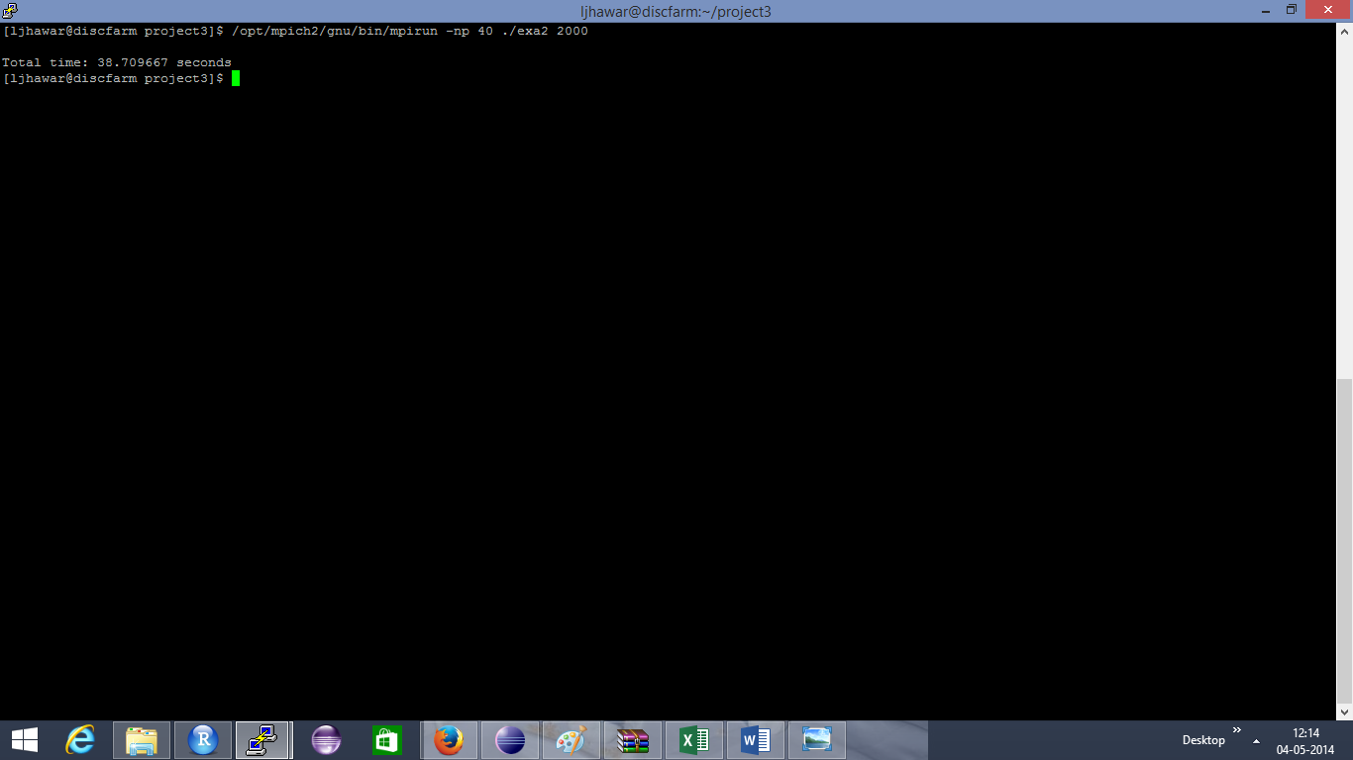

## Table:

|  |  |
| --- | --- |
| Number of processors | Total time |
| 1 | 24.903709 |
| 2 | 12.558094 |
| 4 | 6.246193 |
| 8 | 3.154792 |
| 16 | 15.442924 |
| 20 | 21.893756 |
| 40 | 38.709667 |

## Plot:

# Question 2 b:

## Output:

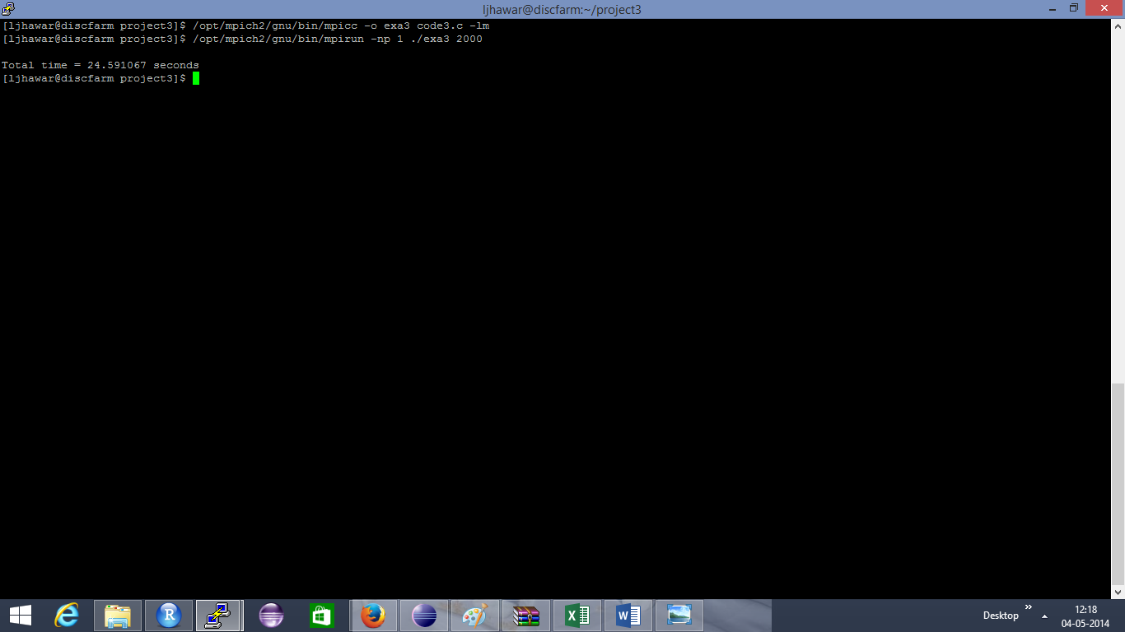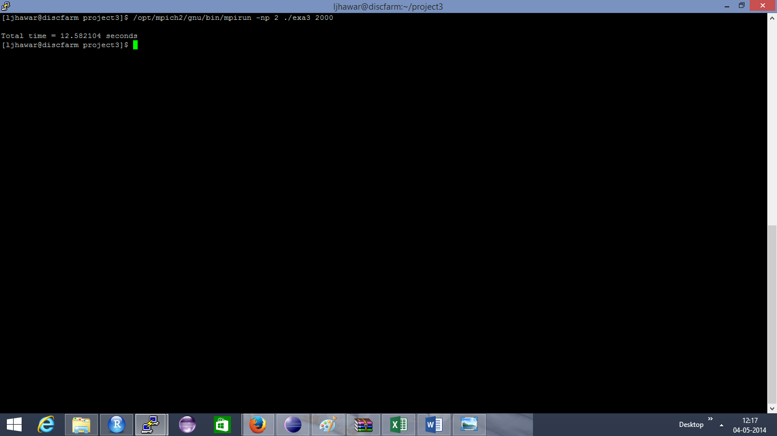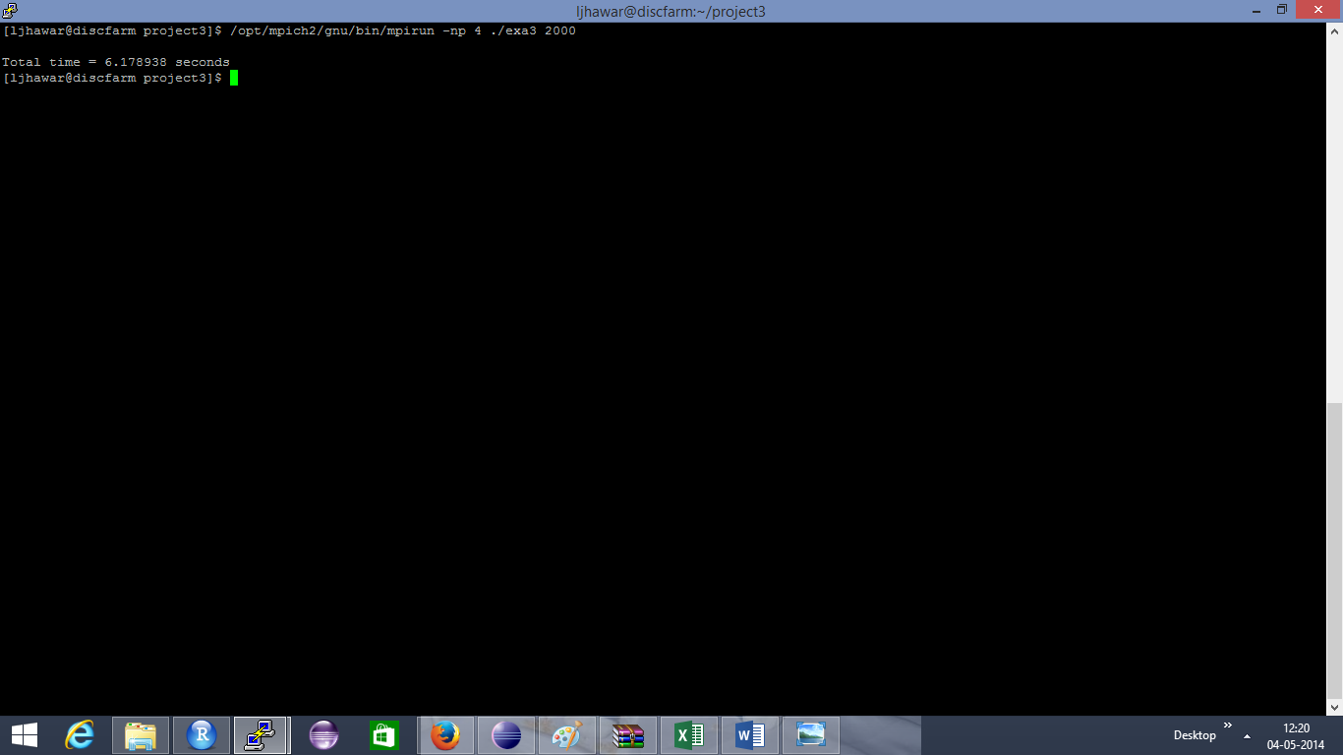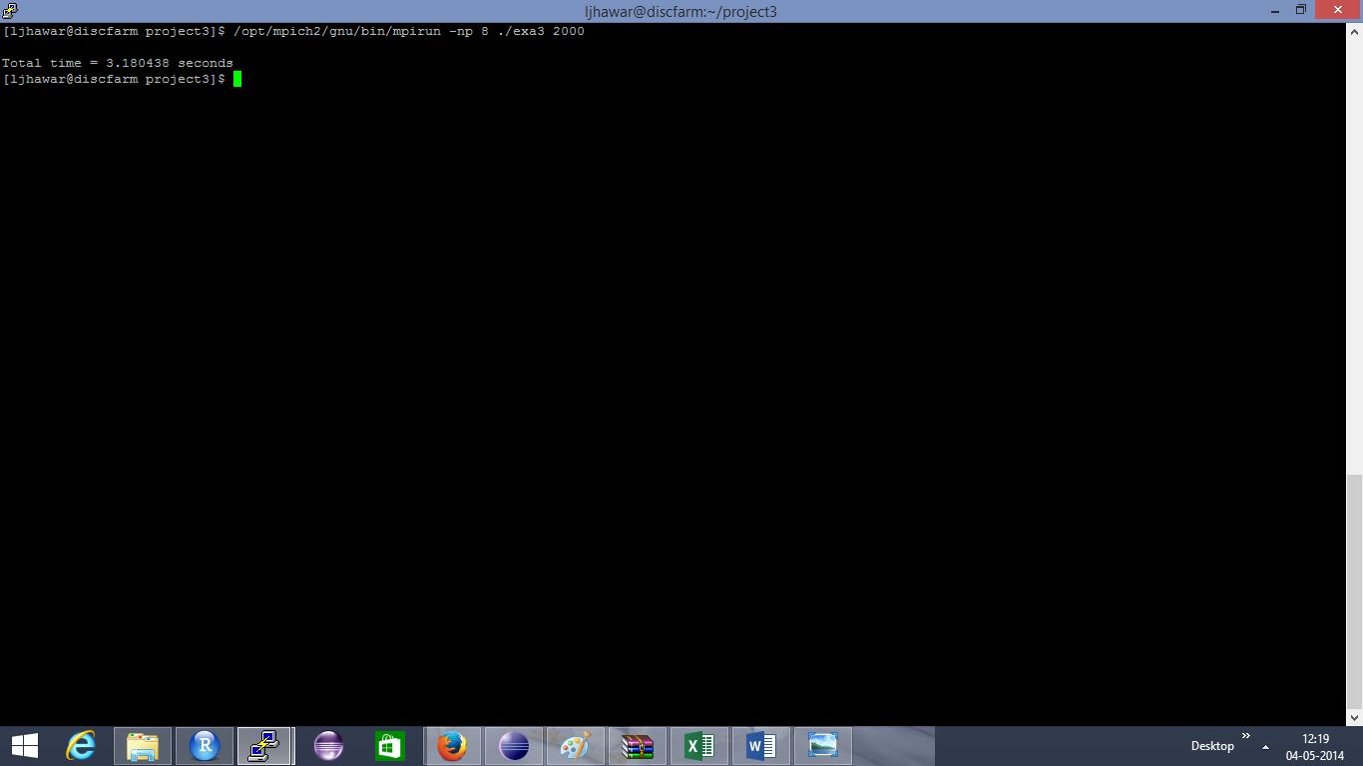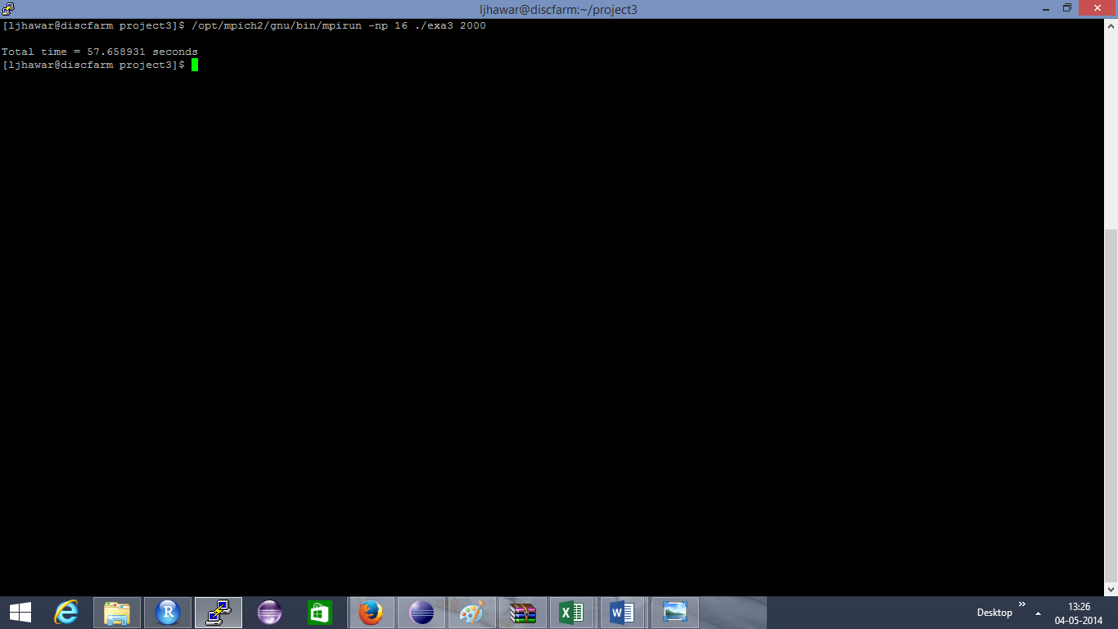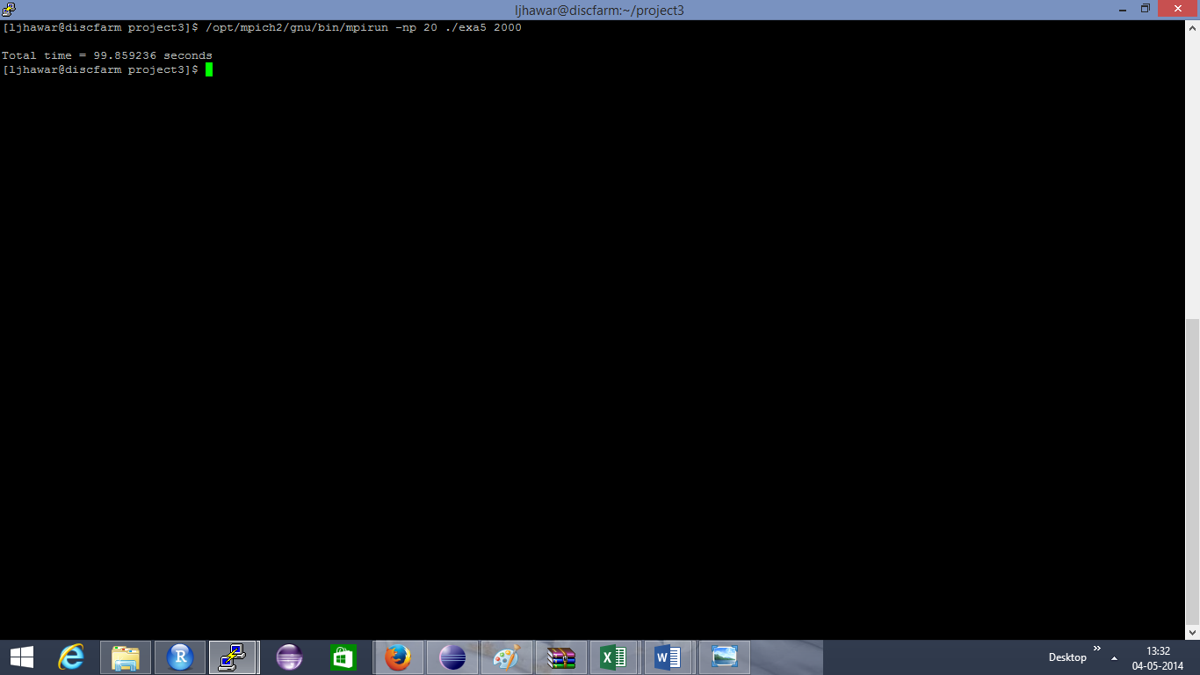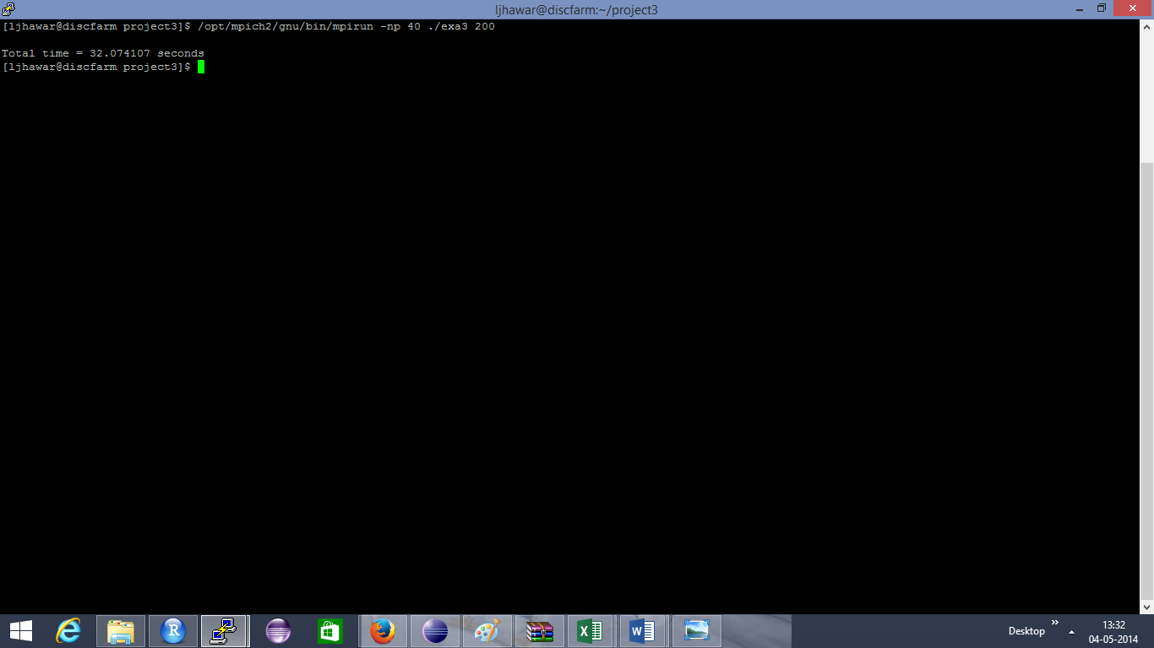

## Table:

|  |  |
| --- | --- |
| Number of Processes | Total time |
| 1 | 24.591067 |
| 2 | 12.582104 |
| 4 | 6.178938 |
| 8 | 3.180438 |
| 16 | 57.658931 |
| 20 | 99.859236 |
| 40 | 32.074107 |

## Plot:

## Comparison Graph: